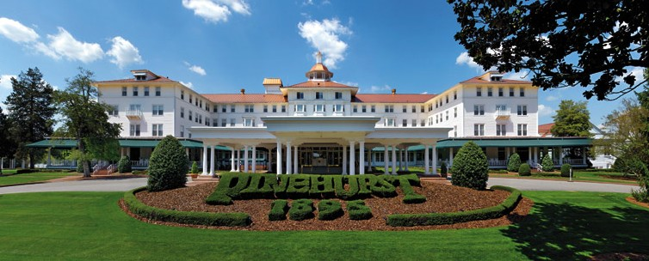

Registration Form:
NCS-­‐ACOFP Annual CME meeting Pinehurst Resort – August 2014
Name: Title: AOA # ( if applicable)
Address: City: State: Zip: EMAIL: (for communication of agenda, etc)

Please register by July 15, 2014. After this date there will be a $50.00 late fee.
Are you a current member of NCS ACOFP? Yes No

Check Type Below:
Member Physician: $ 300 Non member Physician : $ 350 ____ Military, Active Duty: $ 200
Physician assistant or Nurse practitioners: $ 250 ____ Residents -­‐ $50
Spouse/Guest $50

TOTAL REGISTRATION FEES $

PAYMENT: ( 2 options)

- Mail a check to NCS-­‐ACOFP with this registration form to: Robert Agnello
108 Spring Pond Lane,
Spring Lake, NC 28390

- Pay via PAYPAL link on website , and email this registration form to :

membership@nc-acofp.org

