NORTH CAROLINA SOCIETY OF THE ACOFP

ANNUAL CME CONFERENCE
AUG 14th-16^{h} 2015

PINEHURST RESORT & GOLF CLUB - PINEHURST, NC

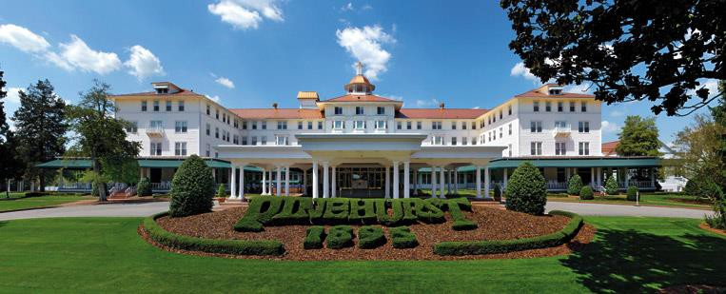
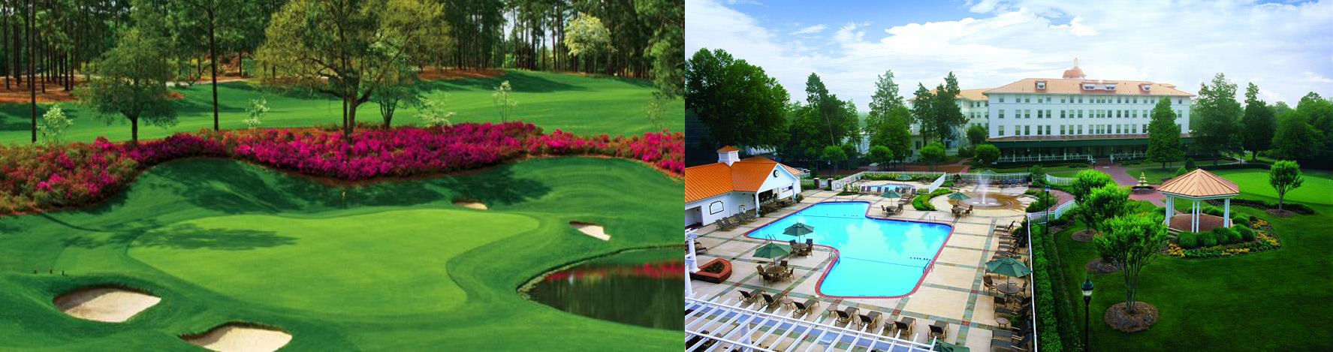
~MEETING BROCHURE and SCHEDULE~

2015 NCS-ACOFP Board of Directors

President: Matthew Kanaan D.O.

President-Elect: Mark Sakr , D.O.

Vice President : Slade Suchecki D.O.

Secretary/Treasurer : Slade Suchecki D.O.

Immediate Past President: Rob Agnello, DO

Founding President: Don Jablonski D.O.

Membership Chair : Ashton Molai, DO

Medical School Representative : Charlotte Paolini, DO

At Large Director : Erin Griffin , DO

At Large Director : Bryan Cox , DO

Advocacy Advisor : Brian Kessler , DO

Resident Board Member: Jelaun Newsome , DO

Student Board Member: Dan Moses and Paul Pikman

Special Guest:
Larry W. Anderson, DO, FACOFP, dist., ACOFP President -Elect

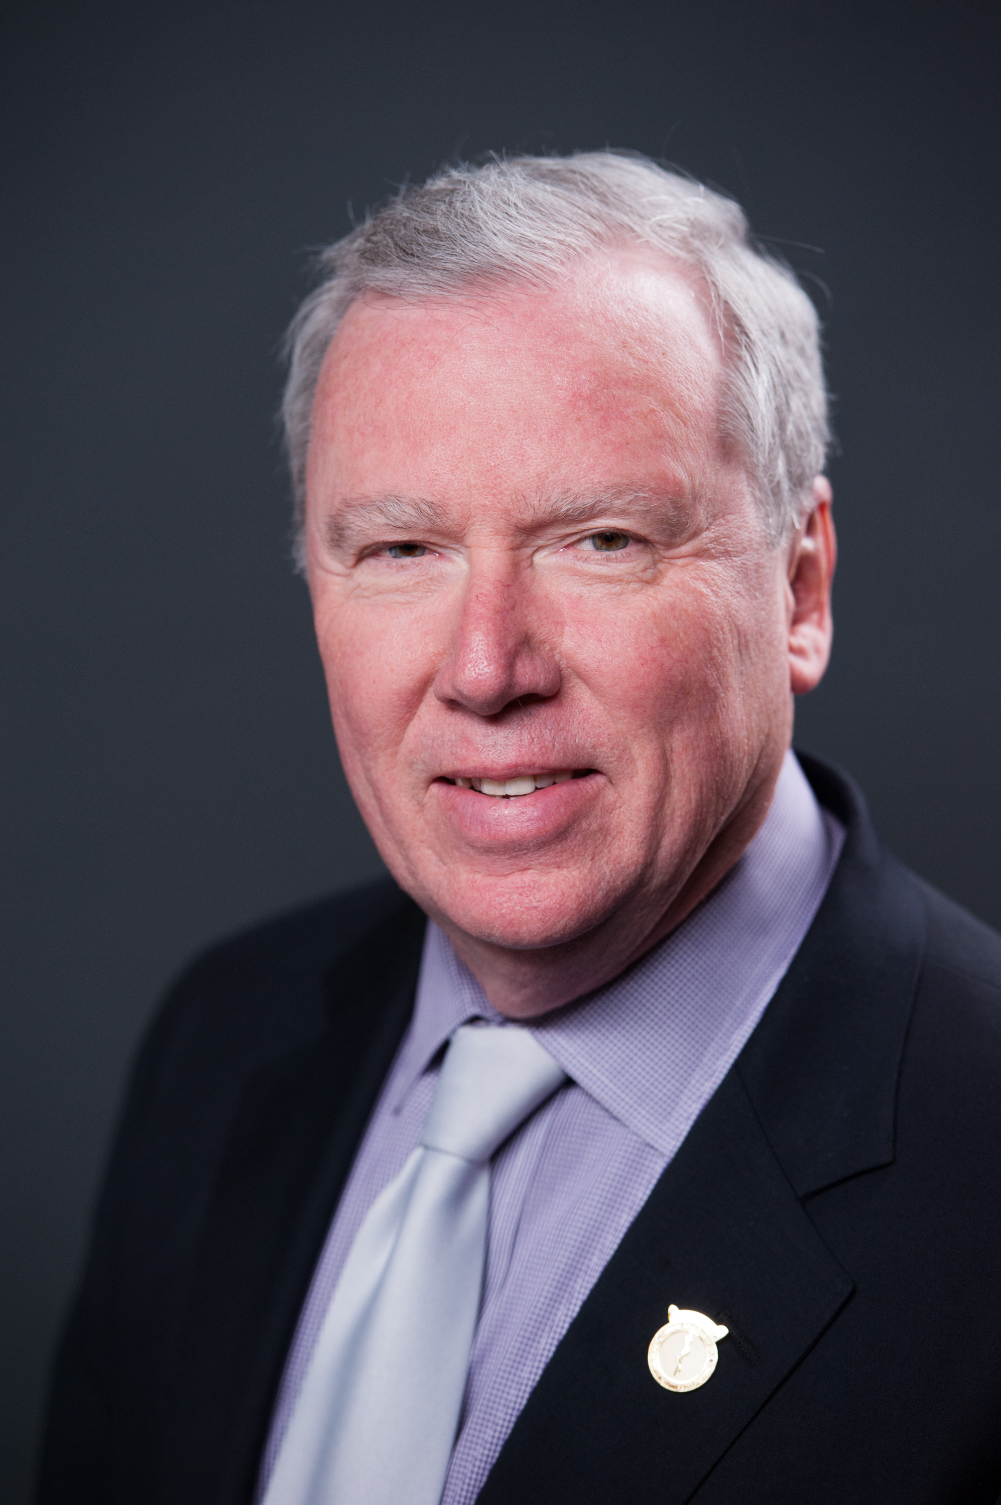

HOTEL INFORMATION:

The Pinehurst Resort in Pinehurst, NC. Call: (800) 487-4653
Hotel convention rate $150.00 /night – identify yourself as member of NCS-ACOFP

GOLF AND SPA. Take advantage of our great discounts at the historic Pinehurst Resort!

HOW TO REGISTER:

Registration details located on the Annual Conference Page on website

WANT TO GET INVOLVED??? : We will be electing some Board Positions during the Saturday Member meeting, and we ALWAYS need volunteers!!!!

DON’T MISS THE:
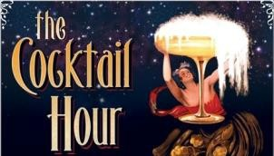

2015 PRESIDENITAL RECEPTION
& COCKTAIL HOUR

Starts at 630pm Saturday in Banquet Room Across from Lecture Hall Dress is Business Casual

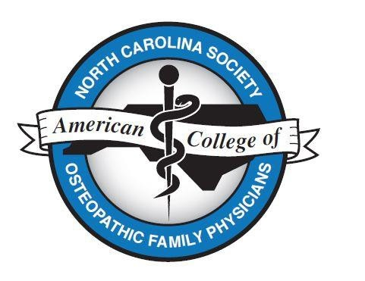

NORTH CAROLINA SOCIETY OF THE ACOFP

ANNUAL CME CONFERENCE & MEETING SCHEDULE

FRIDAY AUGUST 14, 2015

9:00 -10:00am NCS-ACOFP Executive Board Meeting
10:00-11:30am NCS-ACOFP Outgoing Board Meeting

--------------------------------------------------

CME Begins at 1pm
Noon-530pm | Register
1p-2p | Intensive Outpatient Program at Womack Army Medical Center | Kathleen Eaton MD
2p-3p | Low Back Pain Evaluation and Treat | Michael Bartoszek MD
3p-4p | Tipping the Scales:Weight Loss Strategy for Primary Care | Kerry Agnello, DO
4p-5p | Top 5 Things and ER Provider would want a PCM to know | Jamey Hourigan, DO

SATURDAY AUGUST 15, 2014
7:30-8:00am - Breakfast (In Exhibit Hall – Across from Main Room)
8a-9a | OMT workshop - extremities part I | Brian Mulroy DO
9a-10a | OMT workshop - extremities part II | Brian Mulroy DO
10a-1015a | BREAK with exhibitors | -----
1015a-1115a | Role of Extended Hrs Care in Your Practice and Community | Ronnie Laney, MD
1115a-1215p | Controversy over recommendations in Womens Health | Tammy Donoway, DO
1215p-130pm | Working Lunch/NCS ACOFP General Membership Meeting | Larry Anderson, DO
130-230pm | Pharmacology/DM Mgmt | Brock Woodis, PharmD
230-245pm | BREAK with exhibitors | ------
245-345pm | Gynecology/ Womens Health | Elizabeth Hersey, D.O.
345-445pm | Patient Safety | Robert Hasty, D.O

For Residents and Students:
1215p-130pm | Residency Fair/Lunch | --
130-230pm | Student/Resident Mtg - Sports Med Topic | Dr. Neidecker/Martin
230-245pm | BREAK | --
245-445p | Workshop | Dr. Neidecker/Martin
Ongoing | Poster Competition ($50 award d/r reception)

6:30pm - PRESIDENTIAL RECEPTION & COCKTAIL HOUR
(In Large Banquet Room Across from Main Room)
6:30pm – COCKTAILS & HORS D’OEUVRES
7:00pm - OUTGOING PRESIDENT SPEECH
7:10pm - AWARDS for OUTGOING BOARD & INAUGURATION of NEW BOARD MEMBERS
7:20pm - INCOMING PRESIDENT SPEECH

SUNDAY AUGUST 17, 2014
7:00-8:00am - NEW NCS-ACOFP BOARD MEETING (Board Room)
7:30-8:00am – Breakfast in Exhibit Hall
8a-9a | Clinically Integreated Networks - Duke/UNC example | Thomas Warcup, DO
9a-10a | Postural Restorative PT | Chris Poulin, PT
10-11a | Geriatrics | Bret Powell, DO
11-12p | Caring for the Caregiver | Charlotte Paolini, DO

IMPORTANT URLs:
- ONLINE CONFERENCE SURVEYS, AND CME CERTIFICATE Login: your email you registered with
Password: ncsacofp

- ONLINE VIEWING & DOWNLOADS of LECTURES (protected page)
Password : pinehurst

http://www.nc-acofp.org/conference-powerpoints/

LIST OF VENDORS/ FINANCIAL SUPPORTERS FOR THE 2015 PROGRAM
STEWART COMPOUNDING
CAMPBELL UNIVERSITY SCHOOL OF OSTEOPATHIC
NCOMA
NCAFP

SPECIAL THANKS TO ALL THOSE THAT HAVE MADE THIS CONFERENCE POSSIBLE!!!!!

Sincerely,

Your 2015 NCS-ACOFP BOARD

