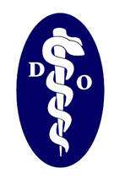

May 18, 2015

Dear Potential Vendor,
We are again making opportunity available to be an exhibitor/vendor at our upcoming meeting of the North Carolina Society of the ACOFP. Please consider joining us August 14th-16th at the Carolina Hotel, Pinehurst, NC. Also we are looking for your general support of our organization. Your presence will demonstrate strong support of our mission.
We anticipate an excellent gathering of osteopathic physicians, allopathic physicians and some nurse practitioners and physician assistants. Also many students from CUSOM will likely be in attendance.
Please reference the attached prospectus for cost and additional information which includes a basic outline of the schedule. Also the following web-site includes the registration link: http://www.nc-acofp.org/annual-meeting/
We look forward to your support and participation.
Thank you,
Robert N. Agnello, D.O.
NCS ACOFP Immediate Past President

