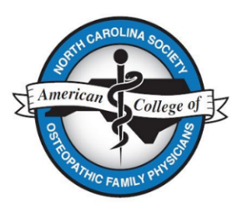

NCS-ACOFP 2024 Winter CME Conference
Real-World Treatment of Obesity - Case-Based Presentations
March 2, 2024, Raleigh NC
Registration Form
Name ______________________________________________________________________
Email __________________________________
Select the Registration Fee Amount Below
Rates: Payment Made by 2/1/24 After 2/1/24
Physicians (NCS-ACOFP Members)* $120.00 $135.00
Physicians (Non-Members) $135.00 $150.00
Active-Duty Military Physician $75.00 $90.00
Health Care Professional (Pharmacist, $75.00 $90.00
Nurse, PA, NP)
Student $25.00 $40.00
Resident $50.00 $65.00
Total Amount Due for Conference $
Dietary Issues
The registration fee includes a continental breakfast. Do you have any dietary allergies?
☐ Yes (If yes, please describe.)
☐ No

Select Payment Type
☐ Pay by check (Make payable to NCS-ACOFP and mail to PO Box 662, Lillington NC 27546.)
☐ Pay by credit card (Register and pay on-line using this link.)
Conference Location
Campbell University Norman Adriane Wiggins School of Law, 225 Hillsbourgh Street Raleigh NC 27603.
*Membership will be verified for each registration.

